Remember to put in derivations.

Zplane example plot:

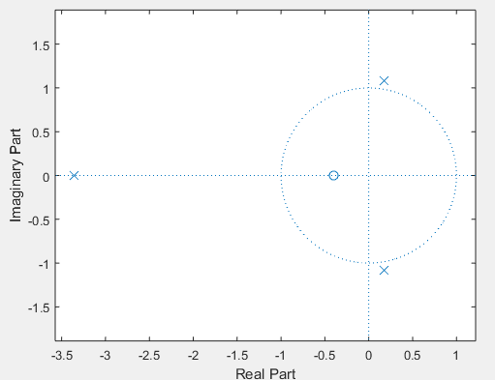

Polls and zero plot in the zplane for the 4th order rational polynomial.

